**Ideation Phase**

**Brainstorm & Idea Prioritization Template**

|  |  |
| --- | --- |
| Date | 17 September 2022 |
| Team ID | PNT2022TMID33110 |
| Project Name | Project – Smart Farmer-IoT Enabled Smart Farming Application |
| Maximum Marks | 4 Marks |

**Brainstorm & Idea Prioritization:**

**Step-1: Team Gathering, Collaboration and Select the Problem Statement**

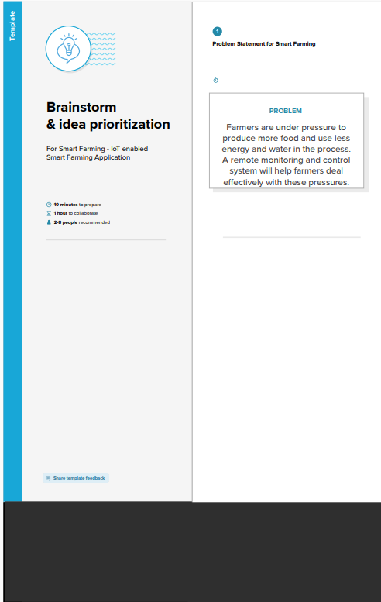

**Step-2: Brainstorm, Idea Listing and Grouping**

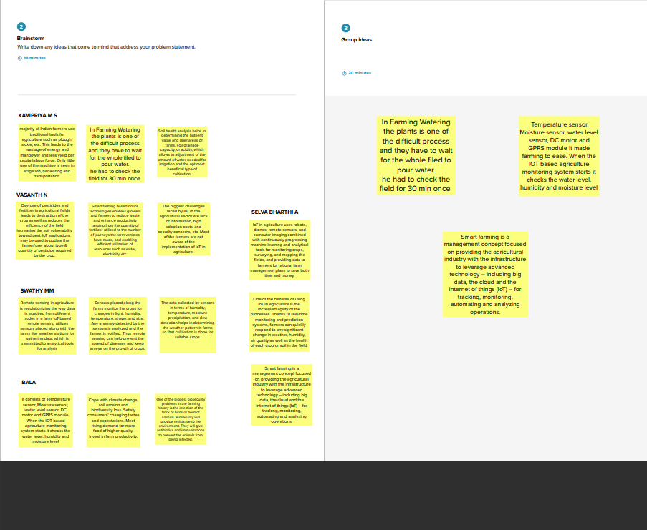

**Step-3: Idea Prioritization**

